**INT 213: Python Mini Project**

**Pre-submission report**

Project title:

Design a system to keep the track of number of pizza orders, delivery of pizzas to a particular venue, order tracking and cancellation of orders.

Project Members:

* Arpan Chaudhary 12113688
* Ayan Ruzdan 12116032
* Vaibhav Jain 12116035

**Modules Used:**

Tkinter:

Tkinter is a standard GUI library for Python. In this project context, Tkinter will be used to create GUI for PMS home, login page, new user page, register and available parking. Various widgets like Button, Canvas, Check button, Entry, etc. will be used to build the Parking Management System GUI.

MySQLdb:

MySQLdb is an interface for connecting to a MySQL database server from Python. In this project context, the database containing user information and consignment information will be connected to our python program using MySQLdb.

**Role and responsibility of group members:**

* Ayan Ruzdan:
  + Will work on the main code and GUI using Tkinter
* Arpan Chaudhary:
  + Will work on the main program and final report.
* Vaibhav Jain:
  + Will work on the database using MySQLdb

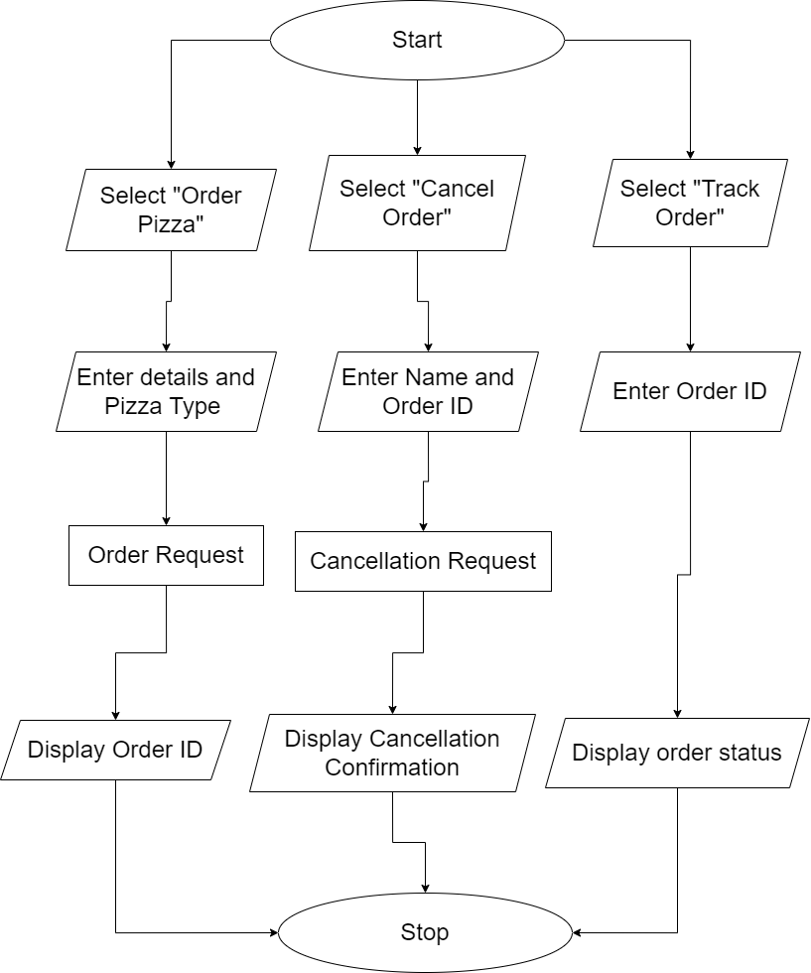**Flow Chart**

**Gantt Chart**